Global Search Workaround (WA-570)
Improve Navigation

- When Search Results are not returned in Fluid, click the home icon.
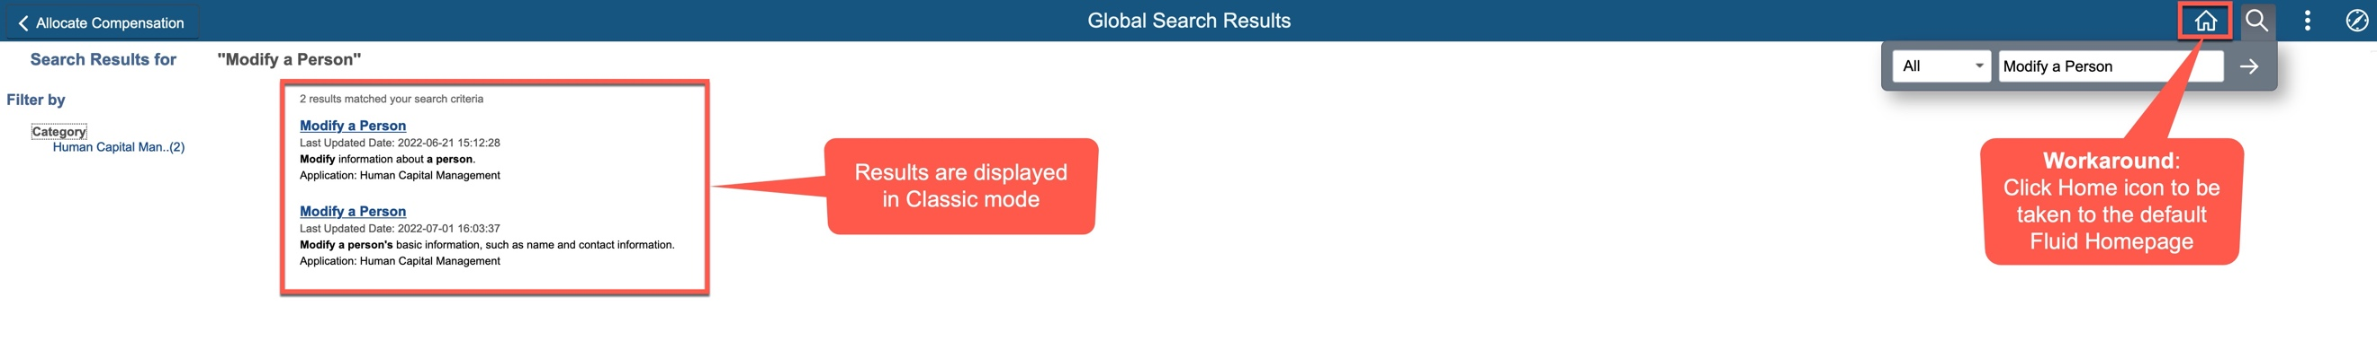

- Re-enter search criteria in Global Search from Fluid Homepage
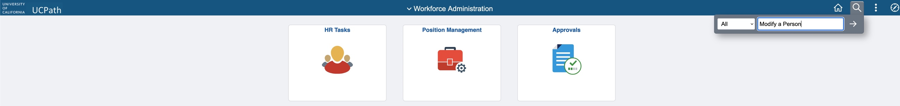

- Results will be displayed in Fluid UI
