UCP-120650
Workaround

Issue: The Fluid Back Button does not track navigation history when accessing pages that have a search record. This occurs when pages are accessed directly from Recent Places, Favorites or Navigator.

Workaround: Use Recent Places on the NavBar to go back to the historical pages that were accessed from either Favorites or Navigator. Additionally, accessing pages from the tiles directly will reduce the need for using the Back Button.

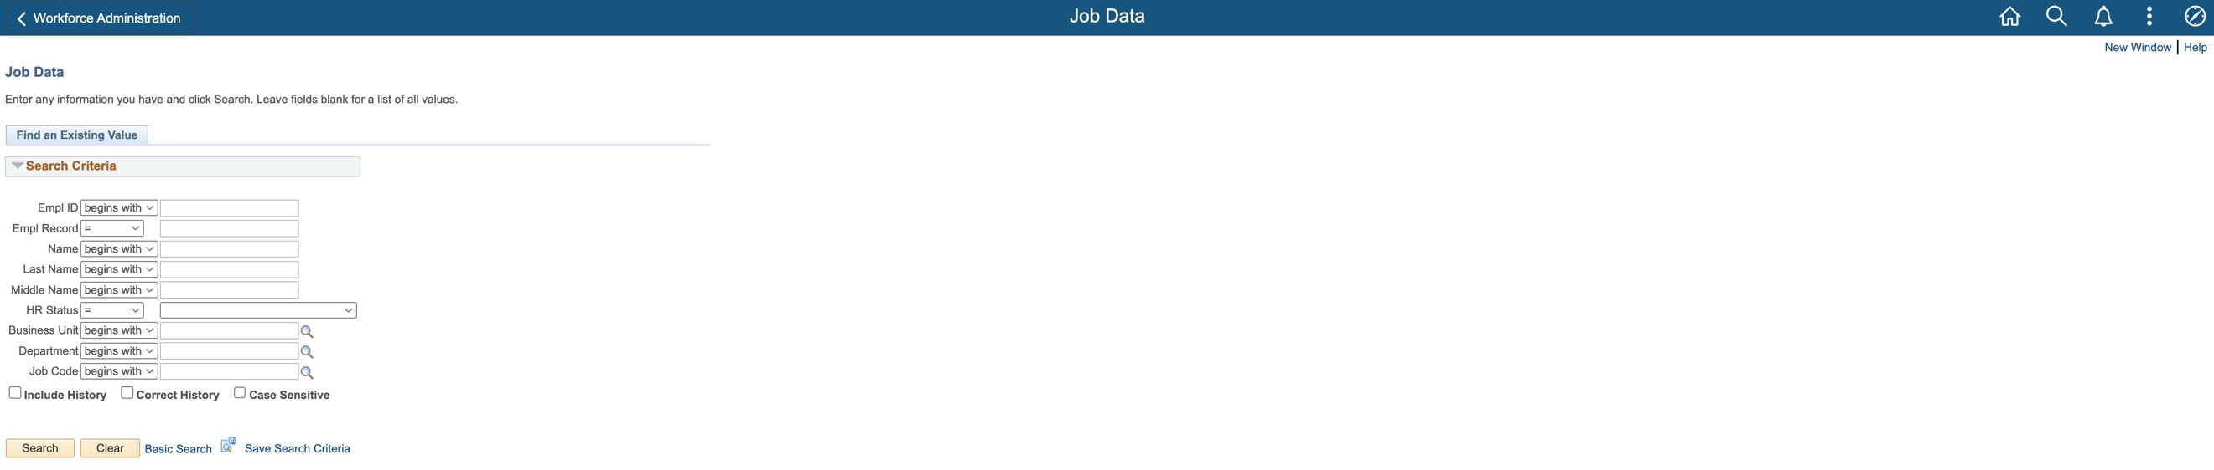
User accesses Job Data from Navigator – Back Button will take them to WFA Homepage

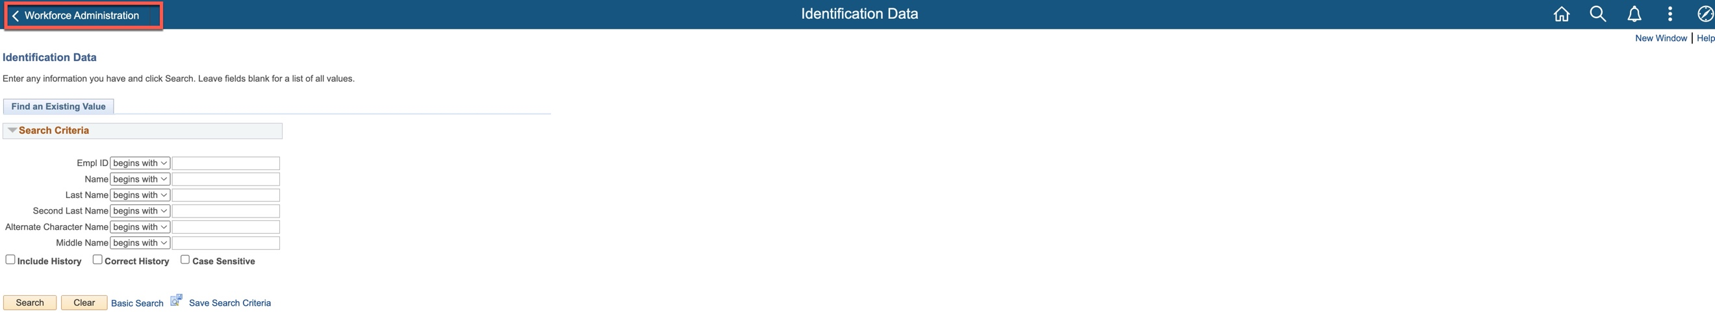
After Job Data, user accesses Identification Data from Navigator – Back Button does not take them back to Job Data.

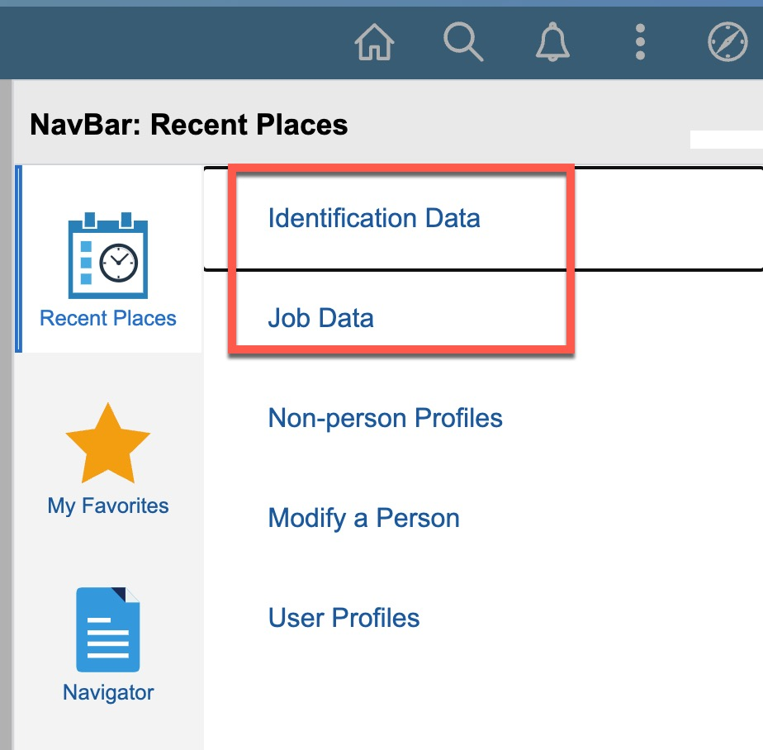
Recent Places will display the last 5 historical pages that were accessed from Favorites or Navigator

